**End-to-End Data Integration and Visualization with Snowflake and Tableau**

**Project Explanation**

First, I created warehouse, database and staging schema.

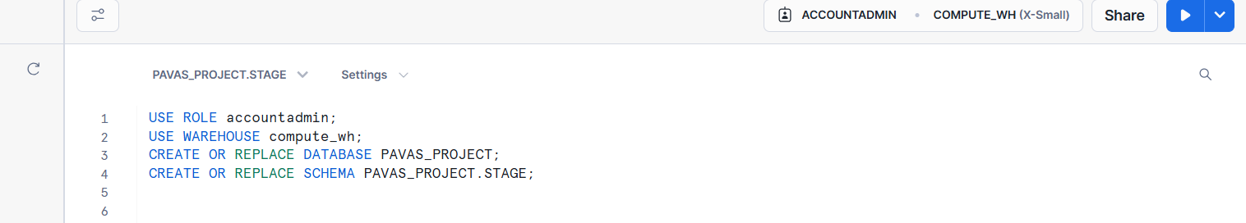

After that I created dimension tables in staging schema

Next, I created fact table in staging schema

I created file format and loaded the dataset in the dimension and fact tables.

Results after loading datasets into the tables

Updating few states names in the customer dimension table in staging schema.

Next, I created new schema named “PROD”

I created new dimension table named “customer dim” in PROD schema.

Transformed the data from customer dim table in stage schema to customer dim table in PROD schema

Next, I created new dimension table named “Product Dim” in PROD schema and copy the all data from “Product dim” in Stage schema to “Product dim” in PROD schema.

Next, I created new dimension table named “Order Details Dim” in PROD schema and copy all data from “Order Details Dim” in Stage schema to “Product dim” in PROD schema.

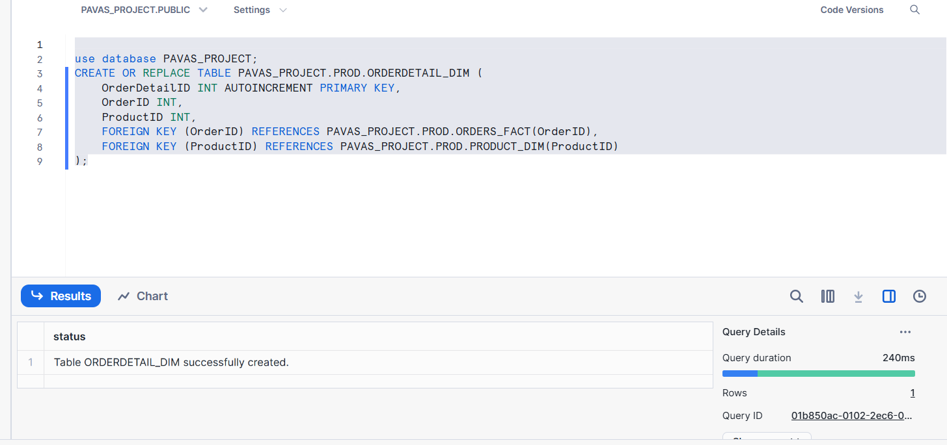

I created new fact table in PROD schema named “Orders Fact”.

Here I split Order Date column in Order fact table in Stage schema into Order date and Order time and update the data separately in the Orders Fact table in Prod Schema.

Results after copying and transforming data from staging schema to production schema be like

Finally, I connected Prod schema to Tableau

Joined the dimensions tables with fact table in the Tableau.

After that I used to do further analysis and visualization in Tableau

